DATA ANALYTICS AND REPORT

DATA SOURCE
The data source used was provided by Betechified for the Capstone Project. This Fintech dataset contains financial and personal information of over 30,000 individuals, including their age, gender, education, job, and region. It shows their income, expenses, savings, credit scores, and debt levels to help understand their financial behaviour. It also includes loan details such as loan type, amount, interest rate, and repayment for those who have borrowed money.

KEY METRICS TRACKED
The key metrics/insights from the data are as follows;
Income and Spending
- Average monthly income: $4,028
- Average expenses: $2,419
- This suggests moderate saving behaviour.
Savings
Average savings: $243,752
Very high compared to income. This could indicate long-term accumulation.
Credit score
Average credit score: 575
Loans
60% of the users do not have loans.
Average loan amount: $100,000
Demographics
Users either unemployed, employed, holds a bachelor degree or are students.
Age: 18-69 years.

INSIGHTS OR TRENDS DISCOVERED.
Customer income remained stable over the years, reaching its highest point in 2024. The large total savings balance of $7.90B shows strong potential for savings and investment products. With 40% of customers using loans, there is opportunity to expand lending services. The average credit score of 575 also highlights demand for credit improvement solutions before customers can access premium financial products.

Users show strong financial capacity, with total income of $130.6M exceeding expenses of $78.45M, but savings discipline varies across groups. High earners overspend due to lifestyle inflation, middle earners struggle with consistency, and low earners face structural barriers to saving. While total savings appear significantly high, the distribution shows that employed individuals contribute the most, while students and unemployed individuals save considerably less. This suggests that income stability plays a critical role in financial outcomes.
Debt reliance affects 40.08% of users, with 63.39% holding low debt, 33.11% in high debt, and only 3.5% in moderate debt, showing a sharp divide. Employment status drives outcomes most strongly, while age improves savings maturity and gender shows little impact. These insights highlight the need for PennyPilot to improve awareness, discipline, and proactive financial guidance.
HOW THE DATA SUPPORTS PRODUCT DECISION
The data shows strong opportunities to introduce savings and investment products due to high customer savings balances. Loan usage indicates potential to carefully expand lending services using credit-based risk pricing. Mid-range credit scores support the need for credit improvement tools, while high expense levels create demand for budgeting features such as spending trackers, alerts, and financial coaching.
The core principle is that every gap in the data is a product brief; low engagement from a segment means unmet need, not absence of demand.
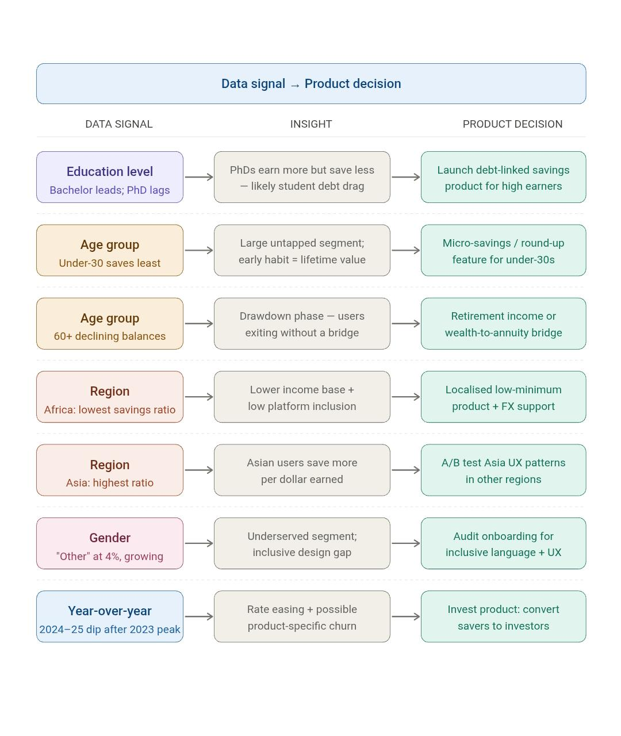
Here's how each data dimension translates into product decisions:

- Education: PhD underperformance calls for a debt-linked savings product, while Bachelor/Master dominance confirms product-market fit.
- Age (60+): Declining balances require a retirement income or drawdown product to retain assets on-platform.
- Region (Africa): Low savings and structural barriers demand lower-minimum, locally-priced savings products.
- Region (Asia): Superior savings efficiency makes Asia the benchmark for UX experiments to replicate elsewhere.
- Gender: Lack of tailored experience requires an inclusive onboarding and UX audit to prevent churn.
- Year-over-Year Dip: Falling savings in 2024–25 signal the need to pivot into ETFs, bonds, or goal-based portfolios.

